

**US Army Corps of Engineers**

**Afghanistan Engineer District**

AED Design Requirements:

Jockey Pumps

Various Locations, Afghanistan

MARCH 2009

**TABLE OF CONTENTS**

AED DESIGN REQUIREMENTS FOR

JOCKEY PUMPS VARIOUS LOCATIONS, AFGHANISTAN

Section Page

**1. General 1**

**2. Jockey Pumps 1**

**3. Pump Selection 1**

**4. Tank Selection 3**

**5. Tank Location 3**

**6. As-Builts 3**

Figures

Figure 1. 24-Hour Profile 1

Figure 2. Duty-Time Profile 2

Figure 3. Variable Speed Pump Curve 2

**1. General**

The purpose of this document is to provide requirements to Contractors for any project requiring the design and construction of jockey pumps.

**2. Jockey Pumps**

Jockey pumps are variable speed pumps used in conjunction with the main water distribution system pumps. A typical pumping system may include two pumps, each capable of handling average daily flow and a third larger pump that will be used during peak flow. The system will operate, during normal times with one of the average daily flow pumps operating. As the demand increases, the second average daily flow pump will activate to increase system pressure and flow. Under extreme demand situations the two average daily flow pumps will be in operation and the third peak flow pump will activate to maintain the necessary pressure and flow within the system. Generally, during the overnight hours the system demand will be much lower than what is provided by one of the average daily flow pumps. During these times the jockey pumps will maintain pressure when the larger main pumps are not necessary due to a reduction in the flow demands on the system. Typically, a hydro- pneumatic tank will be provided with the jockey pump to assist in flow and pressure maintenance.

**3. Pump Selection**

When sizing a jockey pump set it is important to ensure that the performance of the pump can meet the highest possible demand both in terms of both flow rate and pressure and yet not be oversized. The following should be considered when sizing the pump:

The consumption pattern to be met by the pump set, i.e. how much does the consumption vary and how suddenly does the consumption vary.

The distribution of consumption over time. Main pump operating characteristics.

The system size including pump performance and the number of pumps. Hydro-pneumatic tank selection.

The dry-running protection to be selected.

The consumption pattern may be shown as a 24-hour profile or as a duty-time profile as shown below.

Figure 1. 24-Hour Profile

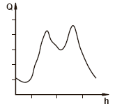

Figure 2. Duty-Time Profile

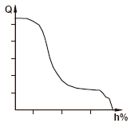

The 24-hour profile shows the instantaneous average consumption during any period of a 24-hour time period. The duty-time profile shows the average consumption based on the percent of the day. The designer should be able to determine this information from the records for an existing system or should be able to predict this information for a new installation based on anticipated uses and expected operational hours. The jockey pump system should be either a duplex (2 pump) or a triplex (3 pump) system. For both a duplex and a triplex system, each pump should produce 50% of the

total flow.

The system head curve for the distribution system can be determined as outlined in the Booster

Pump section of this design manual. The designer should include all head losses associated with the jockey pump system. Using the system head curve the designer should determine the total head that

needs to be maintained and the maximum flow rate for the jockey pumps. This information is then

plotted along the pump curve to select the proper pumps. The best results are obtained when the maximum pressure is within 10% of the best pump efficiency. An example of a variable speed pump curve is shown below.

Figure 3. Variable Speed Pump Curve

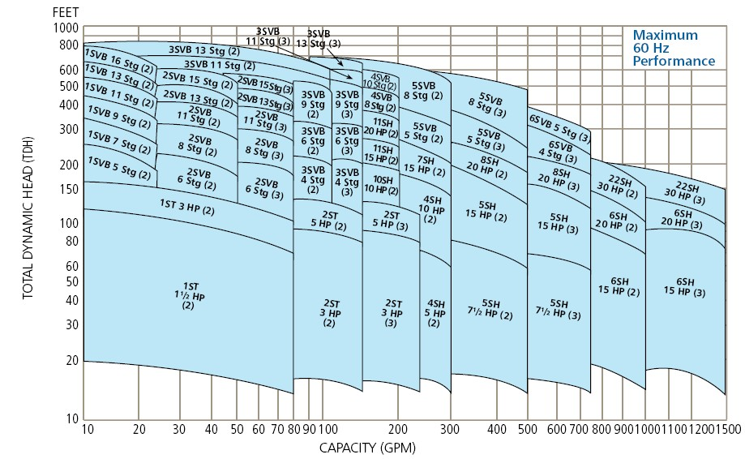

**4. Tank Selection**

For smooth operation and shut-down at zero flow, it is recommended that a pressure tank be sized and included with the jockey pump system. Tank capacity should be between 10 and 25 percent of the maximum flow rate of one pump. If a duplex pump system were designed to so that each pump

would provide a flow rate of 50 m3/hr. then the tank capacity should be between 5 and 12.5 m3. After installation the tank should be pre-charged to a pressure that is approximately 0.7 to 0.85 kg/cm2 below the system pressure. There should not be any water in the system when the tank is pre-

charge to ensure accuracy. When selecting a tank, the designer should make sure that the tank can

support or exceed the maximum system pressure and is compatible with the distribution system.

**5. Tank Location**

The tank should be located in the discharge piping between the pump check valves and the system shut-off valve. The tank connection to the system should be with a full pipe size connection and reducers or “quick disconnect” couplings to the tank which will impede the flow from the tank during system operations should not be used. There should be no valves or other devices between the tank and the transducers.

**6. As-Builts**

Upon completion of installing the jockey pump system, The Contractor shall submit editable CAD format As-Built drawings. The drawing shall show the final product as it was installed in the field, with the exact dimensions, locations, materials used and any other changes made to the original

drawings. Refer to Contract Sections 01335 and 01780A of the specific project for additional details.